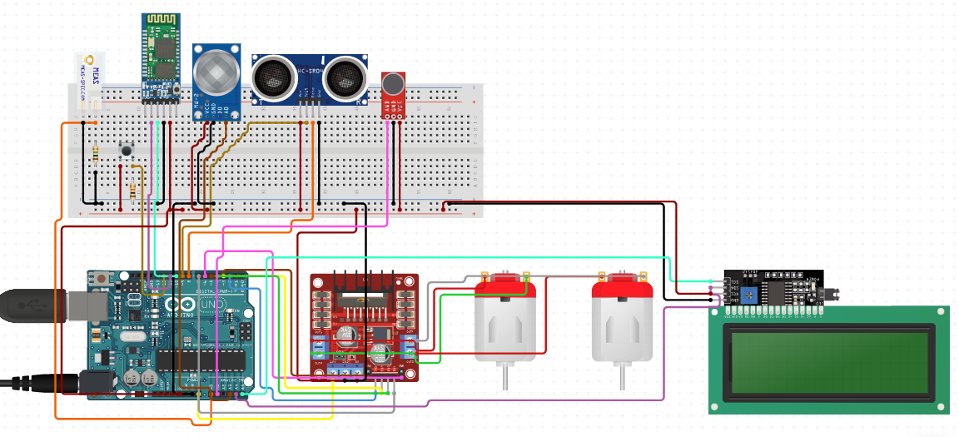In this Project, we have used Arduino UNO as the master control to execute processes. When the Push Button is pushed once, the LCD will show boiling mode and the mechanism will be set to the boiling mode which executes the code that on execution sends the signal to the L289N Motor Driver after 4 minutes and then the motor will turn to switch off the gas supply by turning the Knob.

If the push button is pressed twice in the time period of 3 seconds then the LCD will show milk mode and the mechanism will be set to Milk mode and the ultrasonic sensor will continuously monitor the level of milk, when the milk is about to spill out of the vessel, then the ultrasonic sensor will send a signal to Arduino, in turn Arduino will switch on the motor to cut off the gas supply.

Similarly, when we push the button 3 times then the LCD will show pressure cooker mode and the mechanism will be set to pressure cooker mode and a microphone will monitor the sound of cooker whistle and when it senses the whistle sound, it will send the signal to Arduino which will turn off the Gas Supply.

There will be a Gas sensor installed in the mechanism which will continuously monitor the amount of gas in the environment, when the amount of gas reach a certain value, it will cut off the gas supply immediately by sending the signal the microcontroller.

The Stove is also connected to an android phone through which the user can turn off the gas supply by simply speaking “Turn off”.